Dealing with Document Size Limits

Introduction

The Electronic Case Filing system will not accept PDF documents larger than 35 megabytes (MB).

If the document size is less than 35 MB, it can be filed electronically just as it is. If it is larger than 35 MB, it will need to be divided into two or more documents, with each document being less than 35 MB.

Word Processing Documents

Documents created with word processing software (such as WordPerfect or Microsoft Word) and correctly converted/published to PDF will generally be smaller than a scanned document.

Because of variances in software, usage, and content, it is difficult to estimate the number of pages that would constitute 35 MB. (Note: See “Verifying File Size” below and for larger documents, see “Splitting PDF Documents into Multiple Documents” below.)

Scanned Documents

Although the judges’ Filing Preferences indicate a preference for converting/publishing of documents rather than scanning, it will be necessary to scan some documents for filing, e.g., evidentiary attachments must be scanned.

Here are some things to remember:

- Documents scanned to PDF are generally much larger than those converted/published through a word processor.
- While embedded fonts may be necessary for special situations, e.g., trademark, they will increase the file size.
- If graphs or color photos are included, just a few pages can easily exceed the 35 MB limit.

Here are some guidelines:

- The court’s standard scanner resolution is 300 dots per inch (DPI). Avoid using higher resolutions which create much larger file sizes.
- Normally, the output should be set to black and white. Color scanning is not required but is permissible when needed for special content or to improve the quality of the scan.

- Always review the quality of the scan before filing it. Be sure it is legible.

Verifying Document Size

Because it is difficult to correlate the number of pages that might exceed the 35 MB limit, it is important to know how to verify the document size. There are several ways to verify the size of a document.

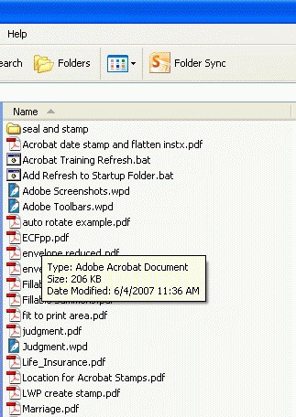
- In My Computer, mouse-over the file name and an information box will appear.

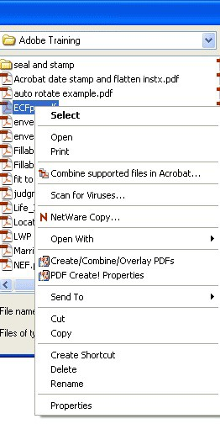
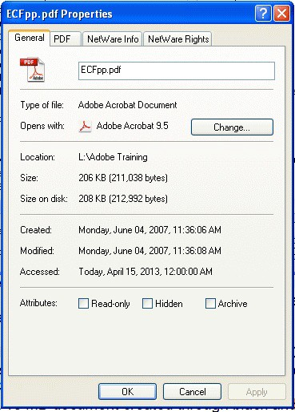
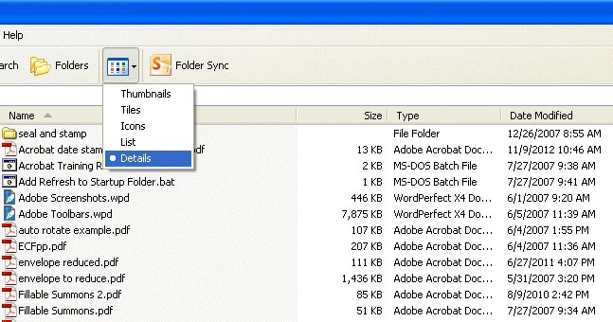
- In My Computer or the Open File dialog box, right-click on the document name. Select Properties. This opens a window that providing file size information.
- In My Computer or the Open File Dialog Box, set the View to Details. The display will include the file name, size, type, and date modified. (NOTE: The details view can also be set in the open dialog boxes of Adobe, WordPerfect, and MS-Word.)

Using Adobe’s Reduce File Size Function

If the PDF document is more than 35 MB, the Reduce File Size function of Adobe may offer a solution.

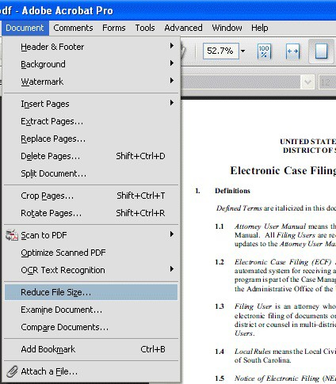
With the document open, choose Document > Reduce File Size. Click OK to accept the defaults. Save with the same or a different file name.

Splitting PDF Documents into Multiple Documents

Because the maximum size limit for filed PDF documents is 35 MB, it may be necessary to split a PDF into multiple documents in order to file a large document. This can be done with Adobe’s Extract Pages function.

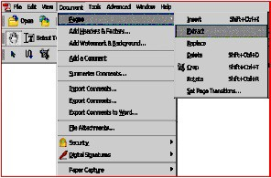
The Extract Pages function in Adobe Acrobat™ provides a simple way to split a PDF document into two or more separate PDF files. You can extract pages from an existing PDF document and use them as the basis for a new PDF document or several
documents. When you extract pages, you can preserve the extracted pages in the original document or delete them. To extract pages from a PDF document, follow these steps:

STEP | RESULT
Open the PDF document that contains the pages you want to extract. Select
Document > Pages > Extract.
In the Extract Pages dialog box, specify a range of pages by entering page numbers in the From and To fields. | 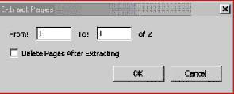
If you want to delete the pages from the original document after extraction, click the Delete Pages After Extracting checkbox. If you do not want to delete the pages from the original document, leave the box unchecked.  Click the OK button to extract the pages. The extracted pages will open as a new document. | 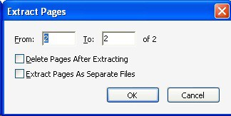
Select File > Save As and then specify a filename and location where you want the extracted pages saved as a new PDF document. | 